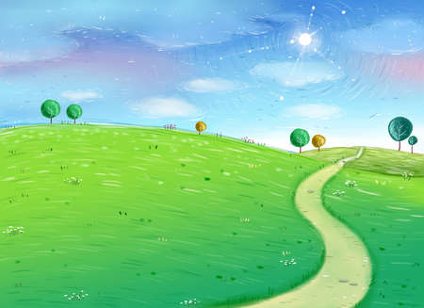

**Understanding the World**

Learn about my body, identifying body parts and their name. Recognise the similarities and differences with others, Begin to think about our senses and link them to body parts.

Introduction to IWB, laptops, camera and iPads.

Walk around our new school and think about the people in school who help us, think about our own families and begin to create a family tree book.

**Personal, Social & Emotional Development**

Become familiar with our daily routines – self register, class calendar & weather.

Learn to line up, find carpet space and access provision/ tidy up.

Learn to listen and take turns during circle time activities. Think about our whole school rules and develop a set of class rules.

**Home/ School Links**

Parents reading workshop

Home readers

WOW moments

Stories from home

**Communication & Language**

Sharing our summer holiday experiences

Discuss what we like / dislike about school

Discuss our hobbies, favourite toys etc…

Share nursery rhymes and stories

**Expressive Arts & Design**

Paint & collage portraits

Split pin people

Painting of family and house

3D house

Leaf rubbings / autumn art

**Special Events**

Autumn walks

Harvest festival

Grandparents Day visit

Visit from mum and baby

**Physical Development**

Fine motor skills – brushes, threading beads, sewing, tweezers, playdough,

Eating – snack time, healthy and unhealthy foods

P.E – an introduction

Getting dressed independently, going to the toilet, putting on shoes & coats

** **

**EYFS - Reception**

**Autumn Term 1**

***Our Wonderful Selves***

**Mathematics**

Number recognition

Counting activities to secure 1:1 correspondence

Recognise and name 2D shapes, identifying their properties.

Share nursery rhymes – 5 little ducks, 10 green bottles etc…

Ordering numbers – Order and find the missing numbers in a sequence.

Numbers in context – how old are you, how many people in your family?

**Literacy**

Recognise and write own name.

Understand that print conveys meaning.

RWI – 3 sounds per week

Access a range of texts in the classroom.

Share our favourite stories.

Introduction to HFW