The Teaching of Spelling at Portobello Primary School
Spelling Overview:
We endeavour for all our children to be proficient spellers, who can transfer their spelling skills to all areas of learning in the curriculum and are prepared for a lifelong journey as learners and in their future lives can use their spelling skills to their advantage.

The teaching of spelling is enhanced by the ‘No Nonsense Spelling Scheme’. The scheme is taught discretely three times a week across school. The scheme gives children the opportunity to learn a spelling pattern, practise it, apply it and revisit it.
We constantly strive to create a variety of spelling activities, which are visual, auditory and engaging for the children. Our aim over time is to ensure our children become accomplished, proficient spellers.
A key feature of how we teach spellings is by understanding children's spelling journey. We use the children's phonics foundations to build up their spelling knowledge. We embrace the differences in all our children and celebrate their individual successes and achievements. Therefore, for children who have spelling as a barrier to writing we provide bespoke personalised learning where planning is adjusted for individuals or groups of learners and the spelling curriculum adapted to avoid overloading the working memory and ensure children remember more, can do more, and make progress.

Assessment:
From Year 2-6 children complete a half termly spelling quiz of a maximum of 40 words. This includes a focus on Common Exception Words and spelling rules. Scores are tracked with children identified for further support. Commonly misspelt words are highlighted for further revision on teacher assessment trackers and shared with the English leadership team.
In Autumn Term 1 children complete a baseline assessment on all of the Common Exception Words taught in the previous year group. For example, children in Year 3 will complete a quiz on the Year 2 Common Exception Words.

The Teaching of Common Exception Words:
At Portobello Primary School we discretely teach Common Exception Words. Teachers focus on the meaning, word class and a definition of each Common Exception Word as part of their retrieval practice activity. In addition, we use Common Exception Words to develop our children’s handwriting and sentence structure.

Teacher Guidance:
A lesson enhanced by the No Nonsense Spelling scheme should follow the following structure (Master slides have been produced for all staff):
Retrieval Practice:
This element of the lesson should focus on recall and revision of previously taught spelling rules and commonly misspelt Common Exception Words. In Autumn Term this will primarily focus on the previous Common Exception Words (For Example, in Year 3 children will recap Year 2 CEW). Teachers should then plan opportunities to revise Common Exception Words and spelling rules taught throughout the year.
Teaching strategies may include:
- Bingo
- Hangman
- Spotting missing words
- Use of No Nonsense Spelling resources to supplement revision.
- Short writing tasks
- Interaction with class spelling working walls.
- Searchlight – focus on vowels in a word.
Read:
The next part of a lesson should focus on the spelling rule introduced in accordance with No Nonsense Spelling progression documents. The contents of each lesson are set out within each year groups progression documents. The focus of a lesson may change and should be adapted by teachers in accordance with their classes needs. An example lesson overview for Year 3 is shown below:
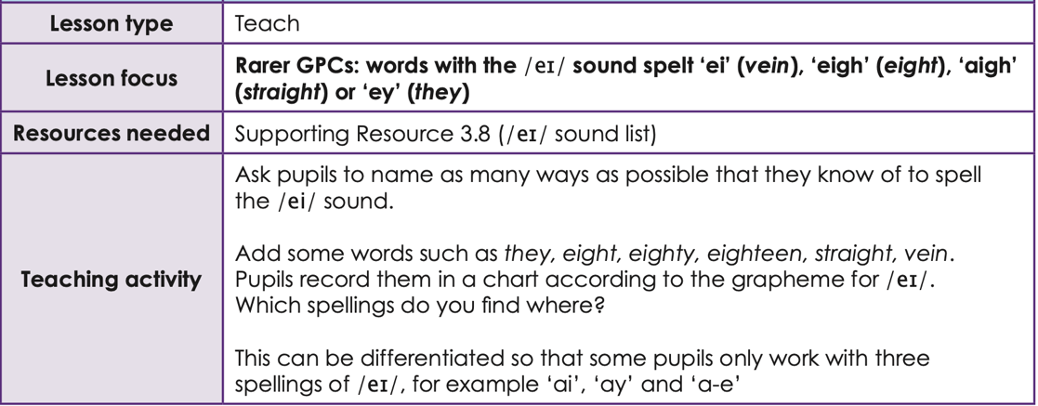

Apply:
Each lesson should conclude with an opportunity for children to apply spelling rules and Common Exception Words in their spelling journals. Activities may include some of the following:
Spelling Strategies (Apply)

Look, say, cover, write, check | This is probably the most common strategy used to learn spellings.  Look: first look at the whole word carefully and if there is one part of the word that is difficult, look at that part in more detail.  Say: say the word as you look at it, using different ways of pronouncing it if that will make it more memorable.  Cover: cover the word.  Write: write the word from memory, saying the word as you do so.  Check: Have you got it right? If yes, try writing it again and again! If not, start again – look, say, cover, write, check.
Trace, copy and replicate (and then check) | This is a similar learning process to ‘look, say, cover, write, check’ but is about developing automaticity and muscle memory.  Write the word out on a sheet of paper ensuring that it is spelt correctly, and it is large enough to trace over. Trace over the word and say it at the same time. Move next to the word you have just written and write it out as you say it. Turn the page over and write the word as you say it, and then check that you have spelt it correctly.  If this is easy, do the same process for two different words at the same time. Once you have written all your words this way and feel confident, miss out the tracing and copying or the tracing alone and just write the words.
Segmentation strategy | The splitting of a word into its constituent phonemes in the correct order to support spelling.
Quickwrite | Writing the words linked to the teaching focus with speed and fluency. The aim is to write as many words as possible within a time constraint.  Pupils can write words provided by the teacher or generate their own examples. For example, in two minutes write as many words as possible with the /iː/ phoneme.  This can be turned into a variety of competitive games including working in teams and developing relay race approaches.
Drawing around the word to show the shape | 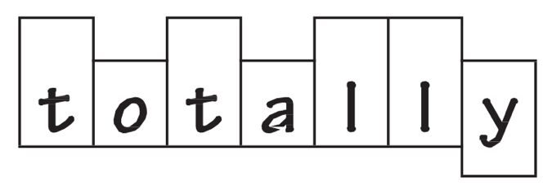  Draw around the words making a clear distinction in size where there are ascenders and descenders. Look carefully at the shape of the word and the letters in each box. Now try to write the word making sure that you get the same shape.

Drawing an image around the word | This strategy is all about making a word memorable. It links to meaning in order to try to make the spelling noticeable.  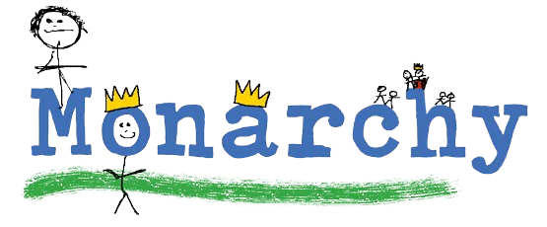  You can’t use this method as your main method of learning spellings, but it might work on those that are just a little more difficult to remember.
Words without vowels | This strategy is useful where the vowel choices are the challenge in the words. Write the words without the vowels and pupils have to choose the correct grapheme to put in the space. For example, for the word field:
Pyramid words | This method of learning words forces you to think of each letter separately.  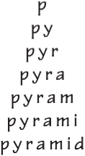  You can then reverse the process so that you end up with a diamond.
Other strategies | Other methods can include:  - Rainbow writing. Using coloured pencils in different ways can help to make parts of words memorable. You could highlight the tricky part s of the word or write the tricky part in a different colour. You could also write each letter in a different colour, or write the word in red, then overlay in orange, yellow and so on.  - Making up memorable ‘silly sentences’ containing the word  - Saying the word in a funny way – for example, pronouncing the ‘silent’ letters in a word.  - Clapping and counting to identify the syllables in a word.

