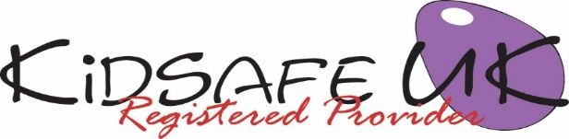

Parent/carer invitation to an information session about KidSafe UK

Dear Parents/Carers,

KidSafe UK is a safeguarding programme for children which your child will soon be receiving. All materials are age appropriate and are delivered without shattering children‘s innocence.

All work is done in an age appropriate, fun and non-scary way through a variety of media including the use of KS our puppet, games, and worksheets.

The KidSafe programme deals with building children’s confidence and self esteem and equips them with effective skills to deal with unsafe situations. KidSafe enables children to value themselves and others and helps them to make wise and healthy choices in their lives. KidSafe teaches children to recognise abuse of all types and helps to prevent it happening in the first place. They learn what is appropriate and what is not appropriate.

Topics covered during the course include:- Raising self confidence; feelings and talking about our feelings; bullying; respecting our bodies; inappropriate touching; secrets; communication skills; assertion – saying No; computer/internet safety; age ratings on DVDs and computer games; how it feels to hear arguing; looking after our mental health and emotional well-being.

You will receive a letter following each session children are taught detailing what has been covered.

In order that we can give more information about the KidSafe programme please attend one of the two parent/carer information sessions we are holding in school. The date and times are below.

These sessions are for adults only – please arrange for child care if you have younger children.

Date Time
First information session:
Second information session:

Yours sincerely,

Head teacher
Visit KidSafe at www.KidSafeuk.co.uk or follow us on Facebook and Twitter

KidSafe UK based in Cumbria has no association with Kidsafe Limited based in Stockport

© Copyright A V Webb & J K Walker 2018 licensed exclusively to KidSafe UK

