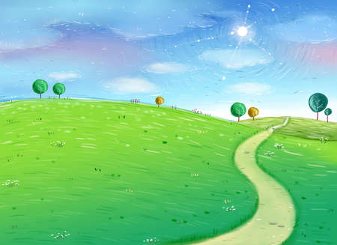

**Personal, Social & Emotional Development**

Become familiar with our daily routines – self register, class calendar & weather.

Learn to line up, find carpet space and access provision/ tidy up.

Learn to listen and take turns during circle time activities.

Why am I special? Describe self in positive terms and talk about abilities.

Learn to choose the resources you need for chosen activities.

**Understanding the World**

Develop an understanding of growth, decay and change over time (autumn walks and habitat building)

Weekend news – Enjoy sharing special times and events with family and friends.

Begin to develop an understanding that information can be retrieved from computers – access age appropriate computer programs.

**Communication & Language**

Begin to introduce a storyline and narrative to role play experiences (shop role play area).

Follow instructions involving several actions or ideas.

Listen to stories accurately, anticipating key events.

**Home/ School Links**

Home readers

WOW moments

Home- learning

**Expressive Arts & Design**

Begin to construct with a purpose in mind and using a variety of resources.

Explore what happens when we mix colours.

**Special Events**

Christmas performance

Washington Arts Centre Panto

Visit from mum and baby

**Physical Development**

Introduction to PE lessons – warming up and cooling down. Can we recognise the impact of exercise on our bodies?

Think about the need to stay safe when tackling new challenges.

** **

**EYFS - Reception**

**Autumn Term 2**

***Our Wonderful Selves***

**Mathematics**

Recognise numerals to10 and sometimes beyond.

1:1 correspondence – count out objects to 10

Begin to count objects beyond 10

Place numbers in order 1-10

Estimate how many objects we can see and check by counting them.

Count out up to 6 objects from a larger group.

**Literacy**

Recognise and write own name.

Segment sounds in simple words and blend them together.

RWI – 2 sounds per week

Introduction to HFW (5 per week)

Introduction to rhyme – Can we continue a rhyming string?