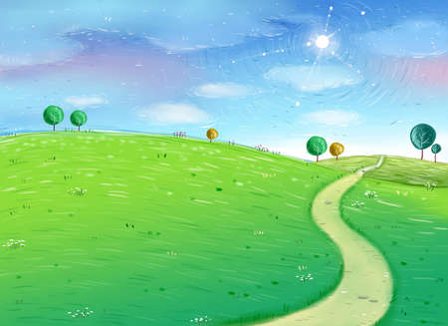

**Computing**

How to use technology safely, respectfully and responsibly. Recognise acceptable and unacceptable behaviour. Digital literacy skills using a range of apps and continue to develop knowledge of animation.

**Modern Foreign Languages**

French – building on our current knowledge and learning new words and expressions.

**RE**

Importance of Worship, places of worship, buildings, rituals and artefacts used in worship in Christian and other religions.

**Creative Learning Journey**

**Year 4**

**Summer Term**

**Egyptians**

**Physical Development**

Invasion games – team games and individual games, improving ball skills and defence and attack techniques.

Developing positive attitudes and values in sport. An external badminton coach will be visiting to provide a fantastic learning opportunity.

**Personal, Social and Emotional Development**

Exploring and dealing with emotions using a Philosophy for Children approach.

UNICEFs Convention on the Rights Of the Child (CRC)

Developing a growth mindset

Learning Powers

**Educational Visits**

We will be receiving a special visitor into school to teach us all about the methods of preservation in the Egyptian times.

**Knowledge and Understanding of the World**

**Science**

Our topics in Science this term are Electricity and Sound so we will be exploring these and developing our Scientific understanding by planning and completing a range of investigations to understand how electricity and sound occur.

**History**

Children will learn about the Egyptians and explore their culture and history.

Learn all about the importance of pyramids and who the pharaoh is and why they were important.

Children will be investigating historical figures and continue asking questions to develop their Historical understanding.

**Geography**

Linking directly to our Topic, Egyptians, we are going to be locating where Egypt is in the world and comparing the cultures there with our own. Understanding and exploring weather patterns and developing our Geographical terms and knowledge.

**Creative Development**

**Music**

We will be continuing to develop our musical understanding by exploring a range of instruments linking to our Science topic and understanding how sound is produced. On top of this, we will be exploring and learning a range of songs all about the Egyptians, Finally, we will continue to develop and explore our understanding of words like pitch, duration and tempo.

**Design & Technology**

Understanding food technology in relation to the Egyptians and what they used to eat.

Using a range of resources to design and then make jars that could be buried in an Egyptian tomb.

**Art & Design**

We will be using the cycle of planning, designing and evaluating a range of Art & Design activities linking to our Egyptians topic.

Confidently investigate the potential of new and unfamiliar materials and use new techniques/ Evaluate his/her work against their intended outcome.