Designated Safeguarding Deputy  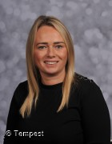  Name: Mrs Lockhart  Title: SENCO  Designated Safeguarding Deputy    Name: Miss West  Title: Deputy Head Teacher  Designated Safeguarding Lead  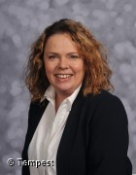  Name: Mrs Humphrey  Title: Head Teacher  Our Designated Persons  Add photo here |  |  |   Use of mobile phones  Whilst on site please:  Use only in connection with your business and when you are approved to do so  - Do not take/use images of children unless approved to do so  - Do not leave equipment unattended  - Ensure that your mobile phones ‘Bluetooth’ capacity is disabled  - Only use your mobile phone in the staffroom or school office  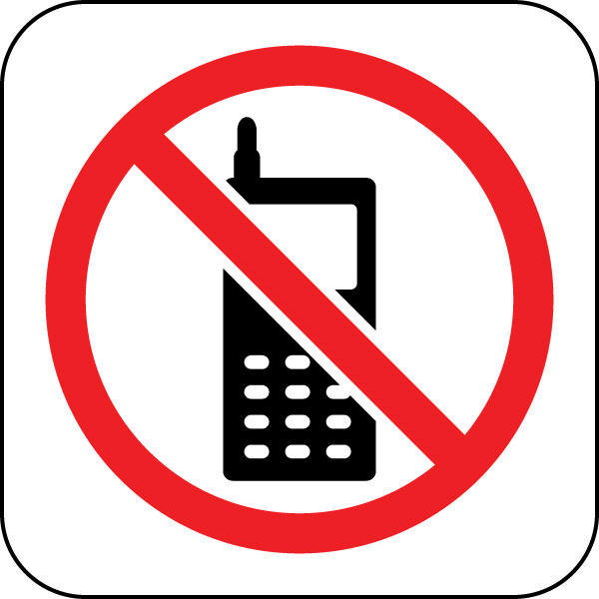  School Contact Details  School Contact details  Address: Portobello Primary School  Tamerton Drive  Birtley  DH3 2LY  Phone: 0191 4104571  E-Mail: portobelloprimaryschool@gateshead.gov.uk |  | 
  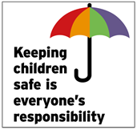
  Portobello Primary School
  Visitor’s Safeguarding Information
  
If you have any questions regarding our fire assembly procedures please ask a member of staff.
General Information
Fire
What to do if a child discloses

- Enter and exit the site from the main entrance and observe signing in and out procedures  - Do not move around the school site unescorted. Please stay within areas that are necessary for your visit  - Please do not interact with children unless instructed by a member of staff to do so.  - You will be issued with a ‘Visitors’ badge, this must be visible and worn throughout your visit. Please return this to Reception as you leave the school site  - Please note that inappropriate behaviour or language on site will not be tolerated, in relation to children, staff and visitors  - An accessible adult toilet is located next to Office reception; please do not use any other toilets during your visit. Please see staff for directions  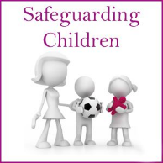 | - If the fire alarm sounds, please leave by the nearest exit  - Report to the fire assembly points which are in either one of the school yards, so that you can be accounted for  - If you are working with children lead them to safety and assemble in the appropriate area  Where your role requires that you interact with children you must:  - Present your photo ID and/or DBS when requested by our Reception Staff  - Wear your photo ID and Visitors Badge at all times when on school site  - Interact with children as required within your professional capacity and report any instances/concerns/observations you may have immediately to a Designated Safeguarding Lead or member of the Leadership Team. (Office staff will provide advice on how to make this contact if appropriate)  Interactions with pupils | Do not question the pupil or try to secure evidence. Your responsibility is to report your concern, not to investigate.  If a pupil tells you something that suggests they are at risk of harm, allow them to tell you as much as they wish and let them know that you must pass the information on to the Designated Safeguarding Lead. (See back of leaflet)  If you become concerned about a pupil’s immediate safety, notify the nearest member of staff and tell them why you are concerned.  You should complete a cause for concern form and hand it to the DSL or a senior member of staff before you leave the school site.  Ask for a senior member of staff if you would like help to complete the form.    January 2024  Record your concern

