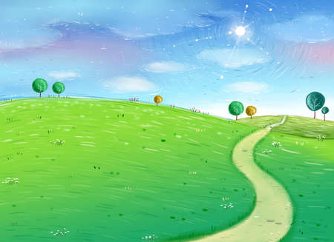

**Personal, Social & Emotional Development**

**Self-confidence and self-awareness** – During Plan, Do, Review time; children will speak in a familiar group, talk about their ideas and choose the resources they need independently for their chosen activities.

**Managing feelings and behaviour –** Children will think about the needs and feelings of others, talking about their own and others behaviour and its consequences. We will create a friendship tree, and think about the qualities that make a good friend.

**Understanding the World**

**People and communities –** Children will begin to identify the similarities and differences between themselves and others, and among families, communities and traditions.

**The World -** Children will make observations of animals and plants and explain why some things occur, talking about changes (Living eggs).

**Technology –** Children will have access to a wide range of technology and will be encouraged to select and use technology for particular purposes (cameras, robots, laptops, iPad, interactive board etc.…)

**Mathematics**

**Numbers –** Children will count and order numbers to 20, saying which number is one more or one less than a given number.

Use quantities and objects to add and subtract two single digit numbers (ELG).

Begin to solve problems including doubling, halving and sharing.

**Shape, space and measure –** Children will use everyday language to talk about size, weight, capacity, position, distance, time and money to compare quantities and objects and to solve problems.

**Literacy**

**Reading –** During guided reading sessions,Children will begin to read and understand simple sentences (ELG), using phonic knowledge to decode regular words and read them aloud accurately.

**Writing –** Write simple sentences which can be read by themselves and others.

Dear Diary – Weekend news Diary

Chick Diary – Living eggs watch

Create signs and labels for classroom

Vets Role play - Writing for purpose/audience

**Physical Development**

**Health and Self Care-** Children will think about healthy foods and develop an understanding of good practises with regard to exercise, eating, sleeping and hygiene.

**Moving and handling –** PE sessions will focus on team games in preparation for sports day – Skipping, running, hopping and bean bag balancing.

**Communication & Language**

**Show and tell –** Provide children with opportunities to answer ‘how’ and ‘why’ questions about their experiences. Encourage children to use past, present and future forms accurately. Children to give attention to what others say and respond appropriately (ELG).

**Home/ School Links**

Home readers

WOW moments

Home- learning

**Expressive Arts & Design**

**Exploring and Using Media and Materials -** Children will safely explore a variety of materials, tools and techniques, experimenting with colour, design, texture, form and function (ELG)

**Special Events**

Visit to Dobbies Garden Centre

Visit to the farm

Living eggs

Sports Day

** **

**EYFS - Reception**

**Summer Term**

***Let’s Grow and Investigate***