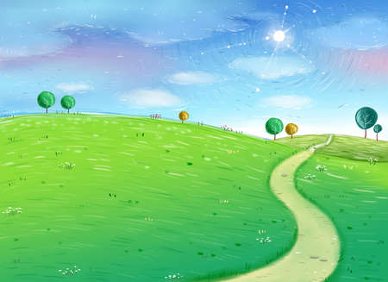

**Computing**

How to use technology safely, respectfully and responsibly. Recognise acceptable and unacceptable behaviour. Digital literacy skills using a range of apps and continue to develop knowledge of animation.

**Modern Foreign Languages**

French – building on our current knowledge and learning new words and expressions.

**RE**

Importance of Worship, places of worship, buildings, rituals and artefacts used in worship in Christian and other religions.

**Creative Learning Journey**

**Year 4**

**Spring Term**

**Under the Canopy**

**Physical Development**

Invasion games – team games and individual games, improving ball skills and defence and attack techniques.

Developing positive attitudes and values in sport. An external badminton coach will be visiting to provide a fantastic learning opportunity.

**Personal, Social and Emotional Development**

Exploring and dealing with emotions using a Philosophy for Children approach.

UNICEFs Convention on the Rights Of the Child (CRC)

Developing a growth mindset

Learning Powers

**Educational Visits**

We will be receiving visitors into school linking to our Rainforest topic. They will be bringing a range of exotic animals to hold and learn about.

**Knowledge and Understanding of the World**

**Science**

Animals including Humans – learning about the digestive system, types of teeth, food chains and bones in the human body.

Living things and their habitats - learning all about classifying animals, vertebrates and invertebrates, habitat surveys and environmental changes.

**History**

Children will learn about the History surrounding the Rainforest and explore deforestation.

We will be using a range of resources to find out aspects of life in the past.

As well as this, we will be looking at representing our learning in an appropriate way.

**Geography**

Linking directly to our Topic, Under the Canopy, we are going to be exploring South America and the Rainforest within. We will be using atlases and maps to locate continents, countries and identifying similarities and differences between these places and our homes. On top of this, we will explore weather patterns across different parts of the world.

**Creative Development**

**Music**

Using a new scheme of work, we will be learning songs and using our voices as instruments.

Listening to and creating our own Rainforest music. Identifying musical elements such as dynamics, texture and exploring natural sounds.

Using instruments to express emotions and produce a range of sounds.

BBC School music all about Jack and The Beanstalk – learning the story through music.

**Design & Technology**

Develop food technology skills linking to the Rainforest topic, understanding about ingredients that would be needed to survive a trek in the Rainforest. Thinking specifically about calories and which ingredients would be best to use.

The children will be creating their own Rainforest, looking at suitable materials and evaluating their properties.

**Art & Design**

We will be using the cycle of planning, designing and evaluating a range of Art & Design activities linking to our rainforest topic.

Develop different ideas which can be used and explain choices for the materials and techniques used.

Confidently investigate the potential of new and unfamiliar materials and use new techniques/ Evaluate his/her work against their intended outcome.