Portobello Primary School

Physical Education Policy

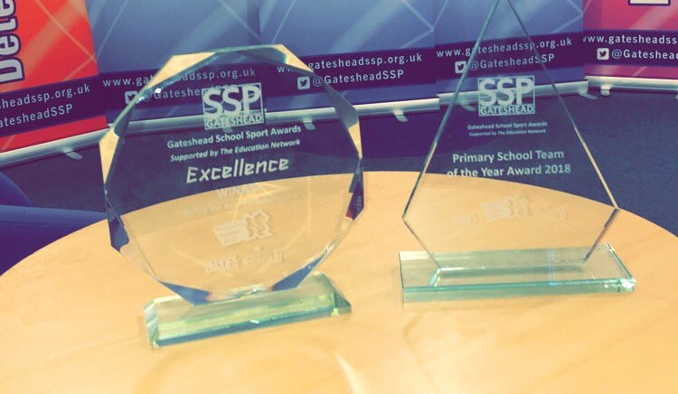
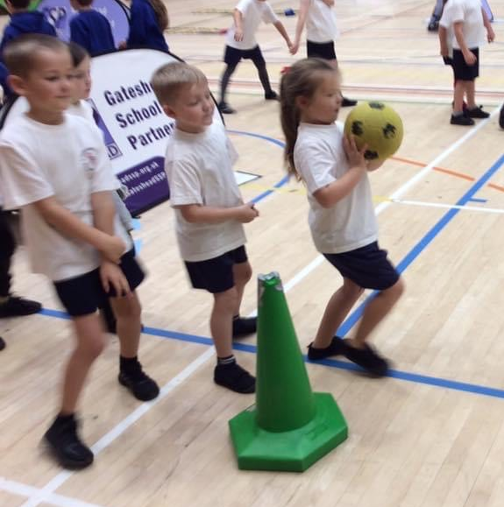

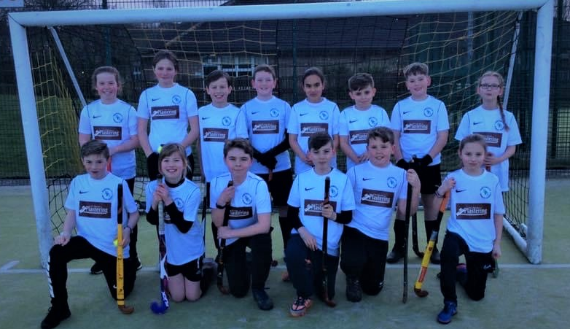

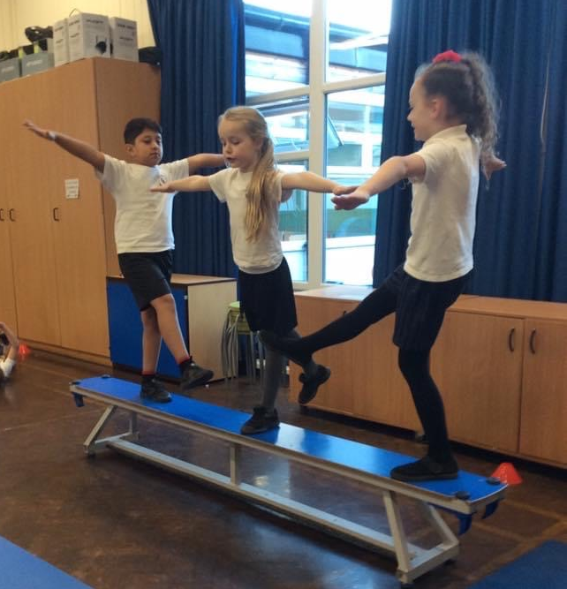

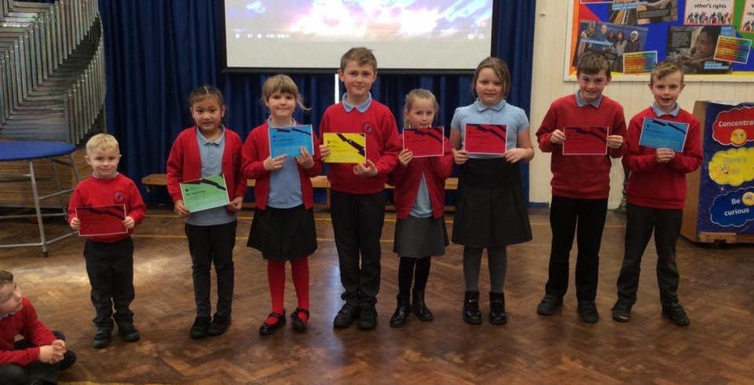

September 2020
To be reviewed September 2023

PORTOBELLO PRIMARY SCHOOL

Policy for Physical Education

Introduction

This document is a statement of the aims, principles and strategies for teaching and learning Physical Education at Portobello Primary School. This reflects the current practice in school.
Vision statement
At Portobello Primary School we fully believe that Physical Education plays a vital role in the development of our children.
Physical Education leads to improved fitness, health and well-being, concentration, attitude and academic achievement. It can help children to:
- Raise their achievement
- Excel in different areas
- Build their self-esteem and physical competence
- Learn to cooperate in a team and display leadership skills
- Experience healthy competition - learn to cope with life’s success and defeats
- To be responsible for themselves and others
- Develop a healthy lifestyle
Through Physical Education children can develop Portobello’s values of: Creating Confidence, Empowering Excellence and Igniting Independence.
We aim to promote a lifelong love of sport and healthy living, keeping fit and encourage children to be the best that they can be. We believe in promoting healthy lifestyles for healthy minds.
Teaching and learning
In Reception class, children are provided with opportunities to be physically active throughout the school day through outdoor play and exploration. This allows them to develop their movement, coordination and control through the use of various types of equipment and different experiences. Children in Reception class also have 2 hours of high-quality timetabled PE per week, where they are provided with a range of experiences through multi-skill activities to develop their gross and fine motor skills, as well as developing their cooperation skills, turn taking, building their self-esteem etc.
All children in KS1 and KS2 are provided with at least 2 hours of high-quality PE per week. The curriculum in KS1 focuses on fundamental skills to develop agility, balance and coordination. Teachers plan a range of lessons including ball skills and team games, outdoor activities, gymnastics, athletics and dance. In KS2, pupils will build on the skills learned in KS1 to apply and develop them in a variety of ways involving a range of games (invasion, net/wall, striking and fielding), gymnastics, dance, athletics and swimming.
Teachers will use a variety of methods when teaching PE and will use key vocabulary and demonstrations to allow children to understand the expectations of taught skills. Children will be given time during lessons to copy and improve on the skills demonstrated and apply them through different activities. Each skill will be broken down into small elements so that pupils can practise them; they may be demonstrated by the teacher or a pupil. It is expected that teachers demonstrate positive attitudes towards physical activity and change into appropriate clothing and footwear for lessons and competitions.
Each lesson will be in 4 parts:
1 – Warming up – Pupils will be taught how to warm up safely for various activities and the importance of why. Children will be encouraged at times to lead parts of this session.
2 – The main part of the lesson – Pupils will work individually, in pairs or small groups as appropriate, to acquire or develop skills. Pupils will also be given the opportunity to select and acquire the use of these skills through small-sided games, sequences or routines. They will learn to evaluate and improve performances.
3 – Competition – Pupils will take part in inclusive competitive activities, against others and themselves, to encourage the development of positive mind-sets such as; determination, resilience, respect and desire to succeed.
4 – Cooling down – Pupils will be taught how to cool down safely and the importance of why. Children will be encouraged at times to lead parts of this session.
Monitoring, Recording and Assessment
Class teacher will monitor children’s progress throughout the year and parents will be informed at the end of each year in line with statutory requirements. Teachers assess children’s skills, knowledge and understanding through observations within PE lessons as well as evaluations and effective use of questioning. Children receive immediate verbal feedback within lessons, as part of assessment for learning so that both children and teachers are aware of the next steps for development. Children are also provided with opportunities to reflect on their own skills as well as receiving peer feedback within lessons, to inform future learning.

Teachers complete assessment grids after each unit to show how children have progressed against the learning objectives from that term and provide details as to what their next steps will be.

Within Foundation Stage, children follow a programme of learning linked to Early Learning Goals for physical development and are assessed against three main areas: Physical, Cognitive and Social & Emotional. Key Stage 2 children complete PE journals after each lesson, to embed the use of key vocabulary and describe their strengths and identify their areas for development.
Inclusion
Our curriculum requires staff to use the principles of STEP to provide all children with opportunities to succeed within PE lessons. This ensures lessons are differentiated in a way that allows all children to participate in lessons, gaining a sense of achievement at their own level.
S = change the space available/used

T = change the length of time for a given activity

E = change the equipment used, e.g. use a larger ball

P = change the people, e.g. group sizes
Physical Activity and School Sport
At Portobello, we are passionate about providing children with a variety of opportunities to take part in regular, high-quality sport and physical activity. We believe that being part of a team is a great way for children to build confidence and self-esteem, as well as allowing children to form strong friendships and develop teamwork skills. We encourage all children to be physically active and take part in sport, competitively or otherwise. Our vision aims to encourage all children to make physical activity part of their everyday life.

Organisation of Physical Education, Physical Activity and School Sport
- All children receive 2 hours of timetabled PE per week.

- Opportunities are encouraged throughout the school day for children to learn through active lessons and experiences that are outdoors as much as possible

- Our Sports Coach, Mr Malia, teaches PE lessons to all year groups. This time is also used as CPD for class teachers to team teach, build their confidence and share good practice.

- Teachers will aim to teach at least 1 hour of PE to their class per week.

- Teachers, Mr Malia and external coaches run a range of extra-curricular clubs throughout the school year, for all children.

PE Subject Leader – Miss H. Tindale

The main responsibilities of the PE subject leader are:

- Help devise and revise the PE policy and schemes of learning.
- Assist the head teacher in explaining school policy to parents, governors and other interested parties.
- Lead staff discussions and assist with school-based service in the area.
- Give advice and support to members of staff.
- Manage budgets in PE alongside the Headteacher.
- Continue professional development through involvement in appropriate INSET programmes.
- Monitor and maintain resources.
- Oversee the provision of extra-curricular activities.

Cross Curricular links

● Where appropriate, the PE curriculum is linked to the Creative Curriculum. For example:
Year 3 – Autumn 1 – History – “Stone Age” dance

● Also, some areas are linked to classes participating in cluster or area schools competitions. For example:
Year 3 – Summer – Athletics – Gateshead Schools

Computing may be used in physical education for a variety of activities. This may include using an iPad or camera to record performances with a view to improving certain aspects. These performances could then be watched on the screen within the hall or classroom. Children could use iPads to assess their own learning and record scores.

PSHE and Citizenship is taught through PE in different ways. For example, children learn to cooperate in different sized groups, make decisions about sequences and how PE can be healthy for you.

SEN / Gifted and talented/Equal opportunities

We believe that all children are special and that all children can experience success and enjoy PE. PE will be taught in line with the school’s SEN and Equal Opportunities policies. Teachers will ensure that equal access and opportunity is provided for all pupils in PE.

Health and Safety

Pupils will be taught:
- About hazards, risks and risk control.
- To recognise hazards, assess consequent risks and take steps to control the risk to themselves and others.
- To explain the steps they take to control risks.

Participation

It is a statutory requirement for children to take part in PE lessons. If a child is not taking part in a lesson due to an illness/injury (with an acknowledged letter from parents,) they will still take on an active role. For example, through evaluating, refereeing, helping organise resources, etc. If a child forgets their PE kit, a child should borrow one from ‘Lost Property’ where possible. Teachers will monitor the regularity of children who are not taking part during a lesson and inform parents if necessary.

Clothing and jewellery

Children will wear the school PE kit for lessons. This should be kept in school during term time and taken home to wash over weekends and holiday periods. It consists of a white t-shirt, plain dark shorts and trainers or sandshoes. During the winter, children should wear dark tracksuit bottoms and a dark jumper. Portobello has a no jewellery policy. Children with long hair should tie their hair back.

Resources

All the PE equipment is stored centrally. There are cupboards located in the hall and the KS2 playground. Within the hall are large apparatus for PE. eg- benches and tressels. Outside, we have fixed basketball nets, as well as portable basketball and netball posts, playground markings and an outdoor play area. There are also fixed outdoor climbing equipment in both the KS1 and KS2 yards. The PE subject leader will maintain the upkeep of the PE resources.

