Learning to read is one of the most important things your child will learn at our school. Everything else depends on it, so we put as much energy as we possibly can into making sure that every single child learns to read as quickly as possible and with good understanding.

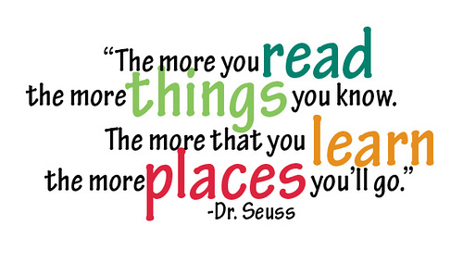
We want your child to love reading – and to want to read for themselves. This is why we work hard to make sure children develop a love of books as well as simply learning to read.

Phonics and Reading in Reception and Key Stage One
We start by teaching phonics in Reception. Children learn how to listen for and identify the sounds in words, how to read them and how these sounds can be written down. Through the specific teaching of phonics children are rapidly introduced to letter sounds which gives them good foundations for learning to read.

High frequency words are introduced alongside reading books for children to develop a good sight vocabulary. The children also practise reading (and spelling) ‘tricky words’, such as ‘once,’ ‘have,’ ‘said’ and ‘where’.

Once children can blend sounds together to read words, they practise reading books that match the phonics and the ‘tricky words’ they know. They start to believe they can read which does wonders for their confidence.

We use both the ‘Oxford Reading Tree’ reading scheme and ‘Dandelion Phonics’ books to support the teaching of reading and phonics in Reception and Key Stage One.

In Key Stage One, children will begin to develop comprehension skills as soon as they are able. Children will be taught to:
- draw on knowledge of vocabulary to help develop understanding
- identify and explain key aspects of fiction and non-fiction
- identify and explain the sequence of events
- make inferences from the text
- predict what might happen based on what has been read

Key Stage Two
In Key Stage Two children will continue to develop reading fluency and comprehension. Some children will continue to access phonics support if required. Children’s reading skills are assessed regularly to make sure children are being challenged and supported appropriately.

We continue to use the ‘Oxford Reading Tree’ scheme in Key Stage Two, which is matched to suit and challenge all reading abilities.

When developing reading skills, and discussing texts, a range of genres will be introduced to children including auto biographies, letters, diaries, short stories, poems and play scripts.

In Key Stage Two children will have focussed reading lessons where teachers will specifically teach reading skills to help develop comprehension and understanding alongside fluency and decoding. Children will be taught to:
- Give and explain the meanings of words in texts
- Retrieve and record information and key details from fiction and non-fiction
- Summarise main ideas from more than one paragraph
- Make inferences and justify these with evidence from the text
- Predict what might happen from details stated and implied
- Identify how information and content is related and contributes to meaning
- Identify and explain how meaning is enhanced through choice of vocabulary
- Make comparisons within a text

Accelerated Reader
Accelerated Reader (AR) is a reading programme that aims to foster independent reading. The internet-based software assesses reading age and suggests books that match pupils’ needs and interests. Pupils take computerised quizzes on the books and earn AR points as they progress. Every child will be given a book level within a reading range, depending upon their reading ability, and will select a book from within that range. This means that the children will have a variety of books to choose from, books which will be sufficiently challenging but also within their reading ability so they can be understood and enjoyed. Our children enjoy using the AR programme from Year 2 onwards at Portobello Primary School.

Reading Plus
Pupils in Year 6 will further develop their reading skills, comprehension, fluency, vocabulary and visual skills using ‘Reading Plus’. This online programme is used several times a week to support and further challenge pupils in developing their reading skills. Pupils are expected to complete Reading Plus tasks as part of their home learning.

To help develop a love of reading, at Portobello Primary School, we actively promote reading for pleasure. Therefore, in addition to their home reading book, children will also have opportunities to read books for pleasure and discuss and recommend books.
Teachers will read aloud to children and they will have regular opportunities to read aloud to teachers and peers.

For help and advice choosing books to read at home with your child, check out the recommended reading book list on our website or visit:
www.lovereading4kids.com

Ongoing Assessment of Reading
Teachers keep an ongoing record of their pupil’s progress in reading, assessing skills and understanding against the National Curriculum Programmes of Study. Progress will be reported to parents regularly throughout the year.

Formal Assessment of Reading
The government ask that we test children on their phonic knowledge and reading skills throughout their primary education. Year 1 children undertake a Phonics Screening Test whilst children in Years 2 and 6 sit end of Key Stage SATs assessments.
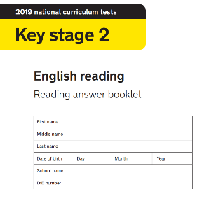
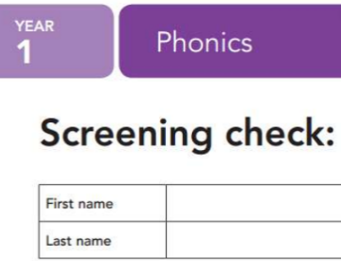
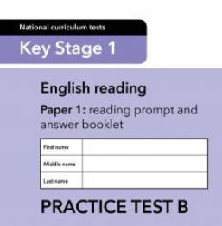

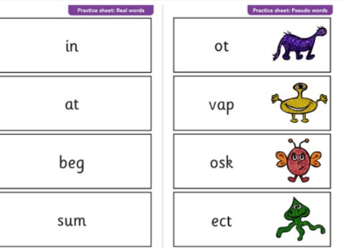
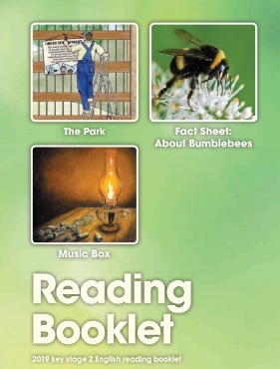

Reading is Fun at Portobello!
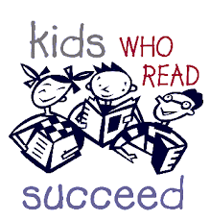
Reading is promoted across the school through special events such as:
- Rewards for reading
- Visits to and from the library
- Author visits
- World Book Day celebrations
- Story telling events
- Book fair
- Shared reading across classes
....and lots more!

How You Can Help at Home
As parents you play a very important part in helping your child to read. Encouraging children to develop a love of books and an interest in language helps their literacy now and makes a difference to their whole future.

The most important thing is that reading should be a positive, enjoyable experience for both the adult and child. To find out more about how you can help with your child's reading, we hold regular parent workshops where you can find out more about your child’s reading. Alternatively, you can make an appointment to speak to your child's teacher. We are always happy to help.

