

Achievement Assembly

This week children have been awarded certificates for keeping improving. Well done to:

Year 1: Hannah Butler Year 2: George Best Year 3: Eisa Khaliq Year 4: Ava Spears Year 5: Ruby Finlay Year 6: Falak Mahmood
Celebrating Attendance

Well done to Year 1 for best attendance again this week! Whole school attendance = 96.8%

General Election – 12th December 2019 – SCHOOL WILL BE CLOSED TO PUPILS

We received confirmation yesterday from the Local Authority that the school building is required as a polling station on the above date. After assessing the risks around these unique circumstances, taking in to account that it could be a potentially much busier election than we are used to, the Governing Body have agreed to close the school to pupils. We apologise for any inconvenience.

Thank you Mrs King-Barnes

We say farewell to Mrs King-Barnes, our school cook, today and would just like to take the opportunity to thank her for hard work and wish her well in the future.

Gateshead Food Bank
We received a lovely thank you letter from Gateshead Food Bank this week following our School Council’s visit. We collected a magnificent 119 kg of food. Thank you very much to all our friends at The Grove Pre-School who came to our Harvest Sing-a-long and brought many more donations. Together we make a big difference to the lives of others.

Poppies Appeal
The Poppy Appeal is the Royal British Legion’s biggest fundraising campaign held every year in November, the period of Remembrance. This year, join us as we mark the end of the WW1 centenary by saying Thank You to all who served, sacrificed and changed our world. Poppies will be available from Monday 4th November.

Children in Need – Let’s Do Good and Feel Good - from the School Council
We invite everyone to come to school in their pyjamas for Children in Need on Friday 15th November. Please bring a £1 or £2 donation and we will take part in special events throughout the day including the Big Morning Move with Joe Wicks!

Key Stage 2 Fruit shop – suggestion from the Year 3 School Council
As you may know our Fruit to Suit tuckshop is open to children in Key Stage 2 on a Tuesday and Thursday. From next week we will be trialling adding fresh apples and satsumas to the collection which can be purchased for 30p each. Thank you to Year 3 for such a good idea!

School photographs
Please note the last day to bring photograph orders to school is Thursday 7th November.
Parents’ evenings - Appointments can be made online from 7am on 3rd November
Tuesday 19th November & Wednesday 20th November
School Calendar and Christmas dates
The school calendar on our website has been updated with key dates for the rest of the autumn term. Please check in regularly as some dates remain out of our control and may change.
Firework Code – ROSPA advice for families






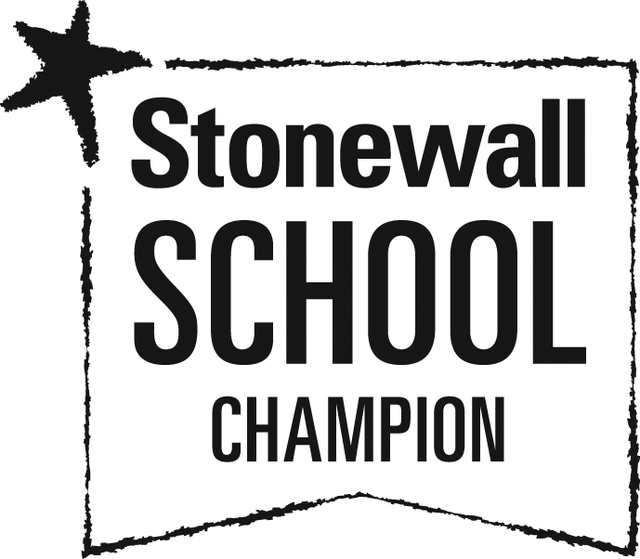
Injury figures support the advice that the safest place to enjoy fireworks is at a large public display - far fewer people are injured here than at smaller family or private parties. But if you’ll be having a firework party at home, you can make the occasion fun and safe for everyone by following the Firework Code, as well as some sparkler and bonfire safety tips. See the ROSPA website for their top tips!

