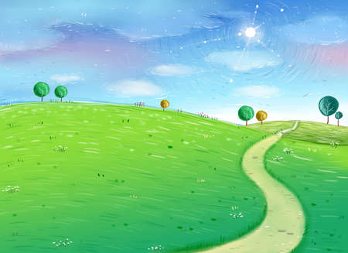

**Physical Development**

Games – team games and individual games, improving ball skills and defence and attack techniques.

Developing positive attitudes and values in sport

**Creative Learning Journey**

**Year 4**

**Autumn Term**

**Digs, Dilemmas and Determination**

**Educational Visits**

Segedunum trip linked to the Romans topic where we will explore the Segedunum site and participate in a workshop using drama.

**Knowledge and Understanding of the World**

**Science**

Science ROCKS…it really does and we will be learning all about the different rocks that from current day, right back to prehistoric times. Thinking about all of the properties, how they can be used and even becoming archaeologists and completing a dig to show our knowledge and understanding.

**History**

Children will learn about the raids and invasions by the Romans. The children will learn who the Vikings were as well as when and where they raided and settled. They will learn about significant events from the period and order these chronologically on a timeline.

**Geography**

We will be using our topic of digs, dilemmas and discoveries to incorporate Geography this term and will specifically be focussing on the Romans and where they invaded. Using this as a chance to identify key areas within the UK on a map and in an atlas as well as highlighting the key Geographical features within the UK.

Using maps and atlases again to look at the different shapes on countries and to explain about natural resources and develop our knowledge of the wider context of places.

**Computing**

How to use technology safely, respectfully and responsibly; recognise acceptable and unacceptable behaviour; identify a range of ways to report concerns about content.

Digital literacy skills (using a range of apps)

**Modern Foreign Languages**

**French**

**RE**

Importance of Worship, places of worship, buildings, rituals and artefacts used in worship in Christian and other religions

**Creative Development**

**Music**

Time and Tune Romans

Children join in with and learn a set of eight songs exploring the history and people of Ancient Rome. The series offers a rich mix of musical skills in performing with voices and simple classroom instruments, body-percussion and listening. Along the way, we will explore a wealth of stories, some true and some imagined. We will be combining the songs with dance, drama, artwork, sets and costumes in exciting performances.

**Design & Technology**

Develop food technology skills linking to the Romans, understanding about the ingredients that would have been used to prepare (and eat) Roman bread. With this, they will understand where ingredients come from and how to combine them in different ways.

The children will be looking into Roman clothing and designing and creating their own Roman shoes, looking at suitable materials and evaluating their properties.

**Art & Design**

We will be using the cycle of planning, designing and evaluating a range of Art & Design activities linking to our Romans topic. This will include designing shields, pottery and mosaics giving the children a chance to:

Develop different ideas which can be used and explain choices for the materials and techniques used.

Confidently investigate the potential of new and unfamiliar materials and use new techniques

Evaluate his/her work against their intended outcome.

**Personal, Social and Emotional Development**

Exploring and dealing with emotions using a Philosophy for Children approach.

UNICEFs Convention on the Rights Of the Child (CRC)

Developing a growth mindset

Learning Powers